Munters Assists With Ensuring Reliability of Unmanned Aircraft Systems
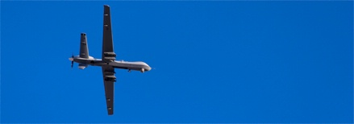
A major U.S. defense contractor has awarded Munters with an order for multiple comprehensive climate control systems that will maintain space conditions during manufacture of the next generation Unmanned Aircraft Systems (UAS).
UAS are unmanned aircraft used for reconnaissance and have the ability to deliver payloads on target. These aircraft need to be as light as possible to increase payload and operational range. This requires the use of advanced composites and fiberglass materials to manufacture the outer skin.
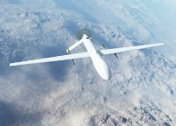
When using these materials to form the required component shape, the control of temperature and humidity in the space is critical to proper set-up and curing. Munters is providing multiple 10,000 cfm Desiccant Dehumidification Systems (DDS) that will include desiccant dehumidification, packaged DX cooling, a self-generating humidification section and a gas fired heating section. The self-generating humidification section is for when the space is too dry and the gas fired heating section allows the manufacture to maintain space conditions during the winter. The maintenance of proper space conditions allows the manufacturer to deliver a high reliability product to the Armed Forces.
For more information visit the defense page.

